**SPONSORS**

**Division F, District 105 Tall Tale Speech Contest 2017-2018**

**Platinum Sponsor:**

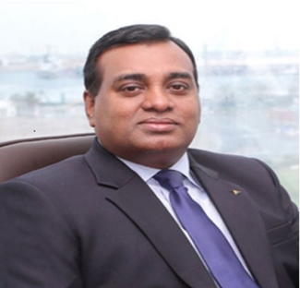

**C.A. JAMES MATHEW**

FCA, CPA (USA)

**C.A. JAMES MATHEW**

FCA, CPA (USA)

**Support Sponsors:**

****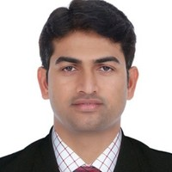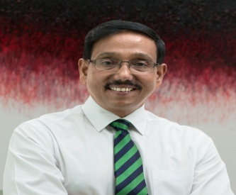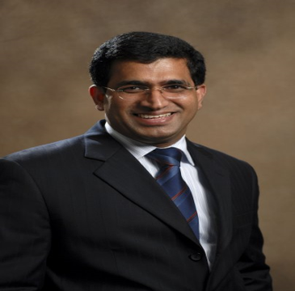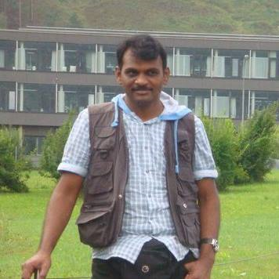

**C.A. ANIL KUMAR**

**NAKIRIKANTI**



**C.A. SHAJU**

**PERINCHERY**

**C.A. RAJU MENON**

**C.A. KRISHNA**

**RAMCHANDRAN**

### C.A. Balaram [Vuchidi](https://ae.linkedin.com/in/balaramv)

**SPONSORS**

**Division F, District 105 Annual Speech Conference 2017-2018**



**C.A. JAMES MATHEW**

FCA, CPA (USA)

**Platinum Sponsor:**

**Support Sponsors:**



**C.A.GOPU NAIDU**

**KGRN**

ACCOUNTING

ASSOCIATES

DUBAI I SHARJAH

ABU DHABI I CHENNAI

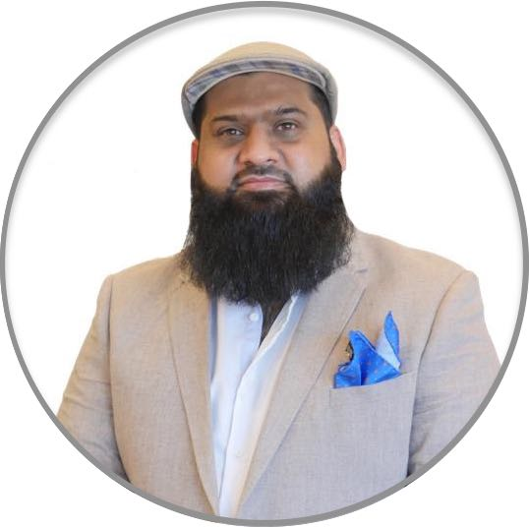

**Shakeel Anwar Chaudhry.**

**A Humanitarian and Serial Entrepreneur.**

**C.A. KRISHNA**

**RAMCHANDRAN**